Power Shell 101

**Module 1B – PowerShell in VSCode**

3/2/2019 Developed by Sam Chung

10/03/2020 Revised by Kim Nguyen

Center for Information Assurance (CIAE) @City University of Seattle (CityU)

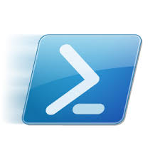

**Learning Outcomes**

* Learn how to install the PowerShell extension in VSCode

**Resources**

* PowerShell in Visual Studio Code, <https://code.visualstudio.com/docs/languages/powershell>

**Activities**

* Installing
* Testing
* Q&A

**Installing**

1. Open your VSCode.  
   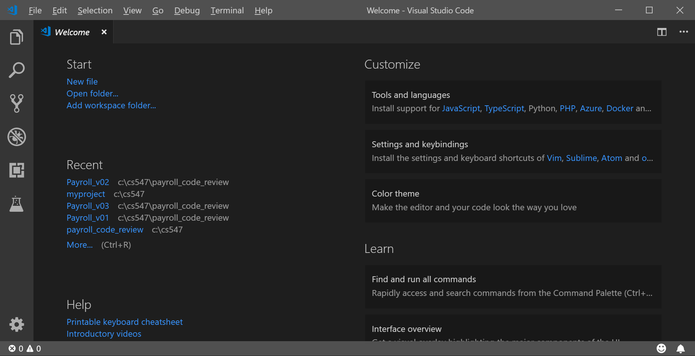
2. Open the Extensions view with keyboard shortcut “Ctrl+Shift+X” and typing “PowerShell” and select the PowerShell extension.  
   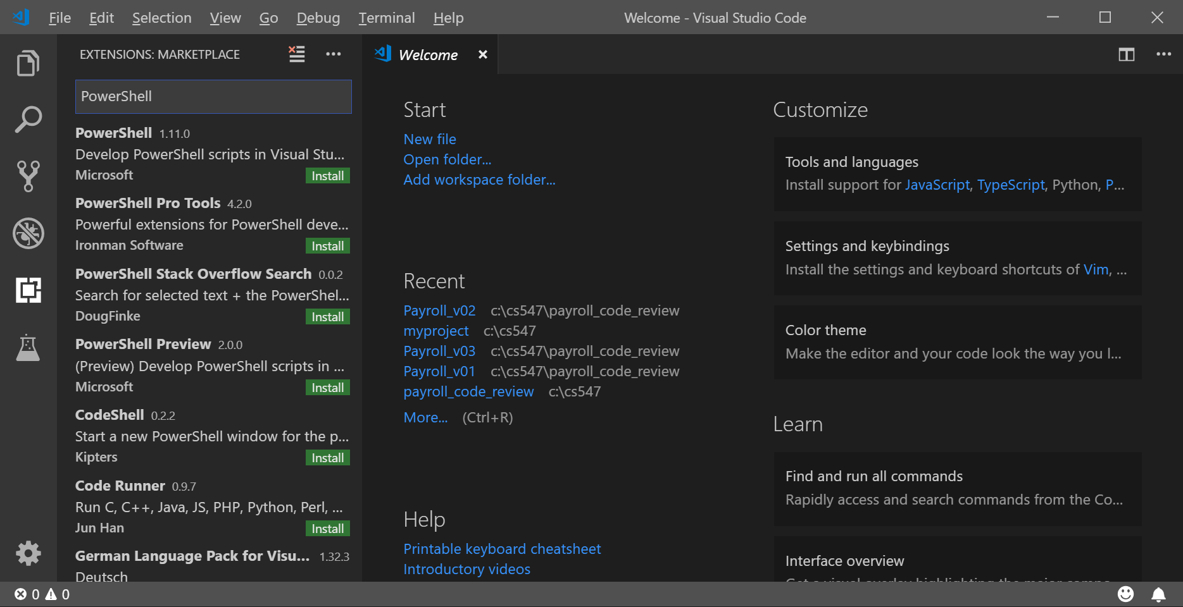
3. Install “PowerShell”

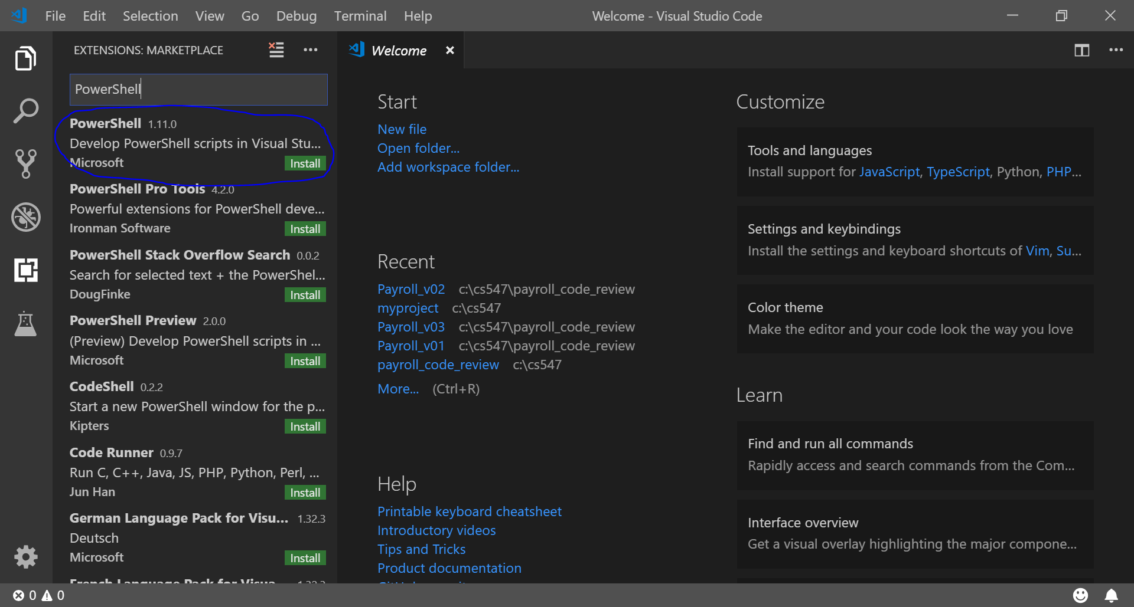

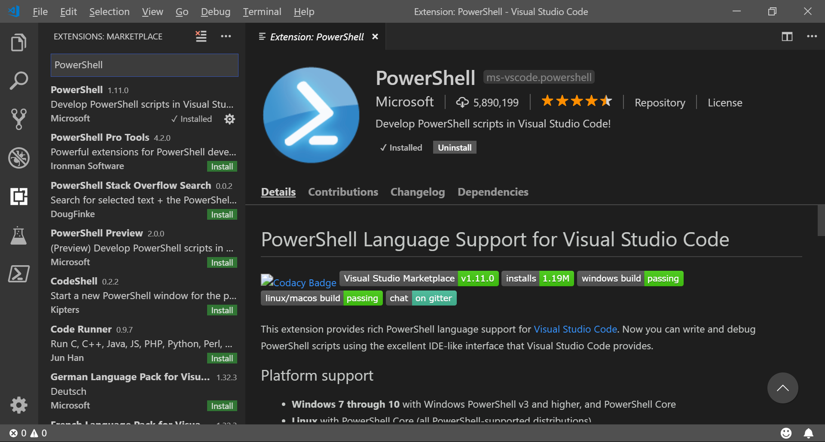

**Testing**

1. To determine what version of PowerShell you have, type “$PSVersionTable.PSVersion”  
   You can see a little table with four columns: Major, Minor, Build, and Revision.

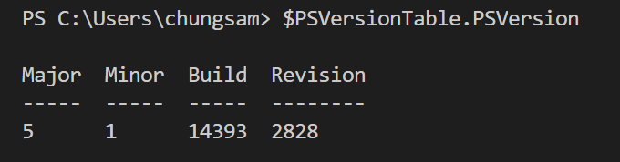

1. When you forget PowerShell syntax or want to learn how a command work, if you type “Show-Command *command*” you can see that a GUI dialog box will be opened to help you complete a command. For example, type “Show-Command Get-EventLog”  
   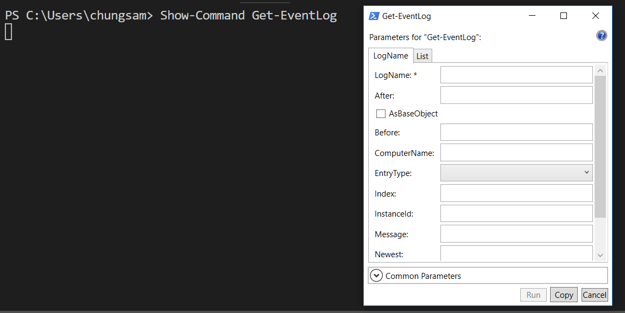
2. To know your current directory, type “Get-Location”  
   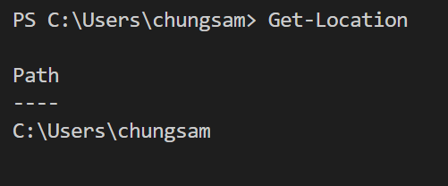
3. To know your current directory, type “get-location” and “gl”  
   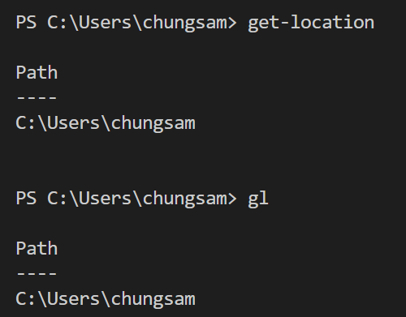

**Q&A**  
Justify your answers with at least one reference.

1. What is PowerShell?

Command prompt used to be called command window. In Linux and OSX it is called terminal window or shell. Many programmers simply call it command line.

-Command line interpreter (CLI) of MS DOS is command.com. For Windows NT it has been replaced by cmd (after its command name) or cmd.exe (after its executable file name), also known as command prompt.

Scripting language of ms-dos is batch. It consists of a series of commands to be executed by the CLI. The term “batch” is from batch processing, meaning “non-interactive execution”.  
  
When a batch file is run, the shell program (CLI) such as COMMAND.COM or cmd.exe reads the file and executes its commands, normally line-by-line.   
  
The filename extension .bat is used in DOS and Windows. Windows NT and OS/2 added .cmd.

1. Why do you need to learn PowerShell

PowerShell is more complicated than the traditional Command Prompt, but it’s also much more powerful. The Command Prompt is dramatically inferior to shells available for Linux and other Unix-like systems, but PowerShell competes favorably. In addition, most Command Prompt commands are usable in PowerShell, whether natively or through aliases.